“ADS Annual Update: Best Practices”
Tuesday, July 28, 2020
12pm-1pm EST

Webinar Attendee Instructions

Please follow the steps “IN ORDER” to successfully connect to the WebEx Meeting

STEP 1 - CTRL+Click or Copy and paste the ENTIRE Web address below into your Web browser:

https://partnersinmeded.webex.com/partnersinmeded/j.php?MTID=mb130573eda6a31453e036f7e9929e3e4

STEP 2 - When the screen loads in your web browser, enter the information in the fields.
- Your name (This is very important to do so that we can provide you with technical assistance)
- E-mail address
- Click “Join”

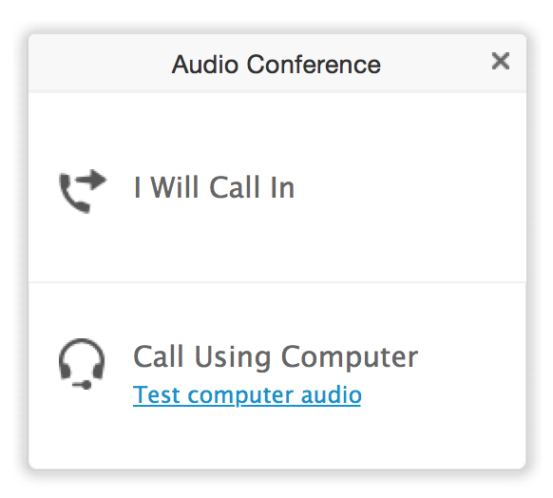
You should now see the WebEx application begin to load. Once it reaches 100%, you should see the presentation title slide appear, as well as a small box with options for audio. An example of this box is below:

From this box, you can choose if you want to listen to the presentation via a telephone or through your computer.

Be sure, if you choose the “Call Using Computer” option, that your computer has reliable speakers.

To proceed, click one of the options on that screen

Please note: PLEASE sign into WebEx on your computer FIRST. THEN connect to the computer audio or dial into the meeting.

If you choose the “Call Using Computer” option, follow the prompts, and you will be connected.

If you chose the “I Will Call In Option”, you will see the box change, as shown below. NOTE: The information in the box below is for demonstration purposes only.
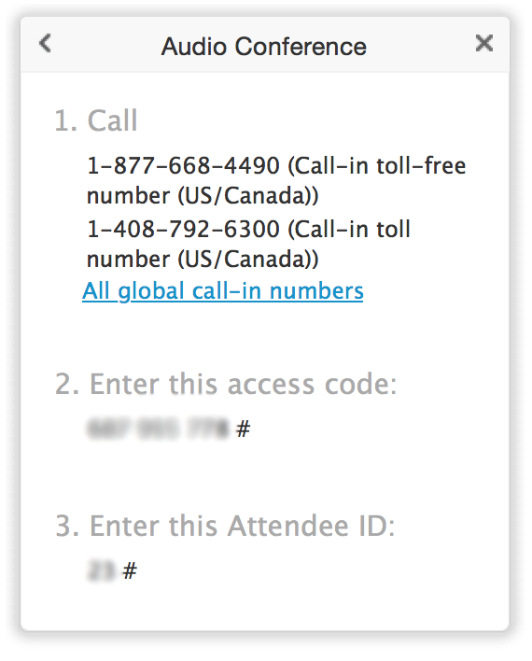

NOTE: After calling 408-792-6300 or

1-877-668-4490, be sure to enter:

The meeting number shown in the box. I have placed it here also, for convenience.

Your Meeting #: 132 403 5273

Your Attendee ID#: It is important to enter your attendee ID in order for you to be able to communicate with the Host.

The box will disappear when you have successfully connected to the audio portion of the meeting.

IMPORTANT NOTICE: This WebEx service includes a feature that allows audio and any documents and other materials exchanged or viewed during the session to be recorded. By joining this session, you automatically consent to such recordings. If you do not consent to the recording, discuss your concerns with the meeting host prior to the start of the recording or do not join the session. Please note that any such recordings may be subject to discovery in the event of litigation.

Tips for a Successful Session

- Be sure to print all materials for the Webinar session
- Everyone will be muted upon entry
- We may be utilizing some technology learning tools like polling; web browsing and annotation so please make sure you keep your keyboard handy.
- Do not put the call on hold. Please hang up and call back if you need to leave the session.
- Please do not call in on a cell phone unless it is absolutely necessary.
For technical assistance, please call WebEx, our Webinar vendor, at:
1-866-229-3239 (available 24-7, US & Canada toll free) or contact Douglas Knox, at douglas@partnersinmeded.com or 724-864-7320.

