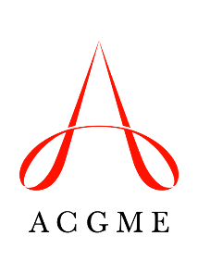
Suggested Annual Program Evaluation and Self-Study Action Plan and Follow-Up Template
Use this template for tracking Areas for Improvement from the Annual Program Evaluations across multiple years. The intent is to create a summary of improvements achieved, and a working list of areas that are still in need of attention. Programs are encouraged to incorporate the Self-Study process into the Annual Program Evaluation. The template is suggested and can be adapted in any way that is useful to facilitate program improvement. Programs can also use attachments or appendices if additional detail is relevant to tracking a given issue.
Note: This form is intended for internal use only and should NOT be shared with the Review Committee or with ACGME Accreditation Field Representatives during accreditation site visits.
 | Areas for Improvement  (AY 2021-2022) | Intervention/Action Plan | Date Instituted/Individual Responsible | Link to Program Aims and/or Context  (Opportunities, Threats) | Expected Resolution  (Outcome Measures and Date) | Status  (Resolved, Partially Resolved, Not Resolved)
1
2
3
….
 | Areas for Improvement  (AY 2020-2021) | Intervention/Action Plan | Date Instituted/Individual Responsible | Link to Program Aims and/or Context  (Opportunities, Threats) | Expected Resolution  (Outcome Measures and Date) | Status  (Resolved, Partially Resolved, Not Resolved)
1
2
3
….
 | Areas for Improvement (AY 2019-2020) | Intervention/Action Plan | Date Instituted/Individual Responsible | Link to Program Aims and/or Context (Opportunities, Threats) | Expected Resolution (Outcome Measures and Date) | Status (Resolved, Partially Resolved, Not resolved)
1
2
3
….
 | Areas for Improvement  (AY 2018-2019) | Intervention/Action Plan | Date Instituted/Individual Responsible | Link to Program Aims  and/or Context  (Opportunities, Threats) | Expected Resolution  (Outcome Measures and Date) | Status  (Resolved, Partially Resolved, Not Resolved)
1
2
3
…

