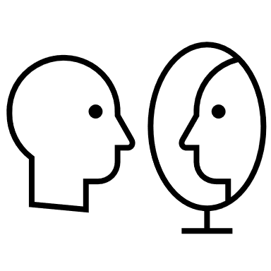
Activity 1: Time for Reflection

Why do this?
One of the strongest learning tools is reflection. If a learner takes a moment to reflect on the knowledge, reflect on the attitudes tied to the knowledge, or reflects on his/her skills in this area, the more likely the learner is to change behavior, deepen the knowledge or increase skill level.
While it takes time away from the “teaching,” reflection makes the teaching more effective.

Very uncomfortable | Slightly uncomfortable | Somewhere between uncomfortable and comfortable | Comfortable | Very comfortable
How do you feel about…
1 | your knowledge of the various virtual learning platforms
2 | providing guidance to my faculty about virtual learning
3 | explaining the difference between synchronous and asynchronous learning to a family member
4 | explaining the difference between synchronous and asynchronous learning to a faculty member
5 | your knowledge of adult learning
6 | your ability to incorporate adult learning into your interactions with residents/faculty

If you have time, please write down an “aha” learning. (An “aha” moment is something you hear or see that you want to remember, or a connection that was made that you didn’t see before)
Why do this? “Aha learning moments” are an efficient way to deepen the learning. Sharing that “aha” with another learner is even better. It also gives a mental break and will create a feeling of “self-efficacy.” (Self-efficacy is the belief that one can succeed and is part of social learning theory.)

