Section I: Program Information  - Program Mission,  - SWOT,  - Aim Statements,  - Previous APE Action Plans, and  - Current APE Action Plans |  |  |  |  | Comments by GMEC or GMEC Subcommittee Responsible for Oversight of APE
- Program Mission
- SWOT | S (Strengths) | W (Weaknesses) | O (Opportunities) | T (Threats)
Add rows as needed
- Aim Statement  Maximum of 5 | Current Aim | Measurement | Type of Support Needed (High, Medium and Low) | Type of Aim (Maintenance or Stretch)
- Action plans from previous APE | Brief summary of action item | Measurement for action item | Status: Resolved, Continued or Removed | Notes about Action (reason for removal of continuation)
- Action Plans from Current APE | Brief summary of action item | Measurement for action item | Person(s) Responsible | Notes about Action Plans
Section II: Accreditation Status
- Letter of Notification | Date of LON: | Status: | Next Site Visit: | Self-study Date:
- Citation Information | Brief summary of citation | New or Extended | Action plan for resolving citation | Person responsible for Action Plans
- Areas for improvement | Brief summary of AFI | Action plan | Person responsible for Action Plans
Section III: Review of Curriculum
Describe how you reviewed the curriculum
Which rotations/services had significant changes in the past year?
Will you be adding or removing any rotations on your block
Section IV: Quality of Safety of Patient Care
How does the PEC evaluate the quality of safety of patient care? Discuss tools that are used to obtain this data.
How does the program use the practice data to help improve patient safety?
Section V: Aggregate Resident & Faculty Activity and Performance
- Well-being | Items in the non-compliant range from ACGME Survey | Number of Well-being Issues during academic year (LOA, taken off rotations, and other well-being issues) | Number of referrals to EAP (not how many actually followed through) | Any well-being issues that were examined on the internal survey? What are the findings?
Residents/Fellows
Faculty
- Recruitment/Retention
Recruitment | Discuss the recruitment strategies that you implemented this past year
Graduation/Attrition | 20__ | 20__ | 20__ | 20__
Residents who started the program 3 years ago
Residents who will graduate at the end of this academic year
% on-time graduation*
*within 2 months = on-time
Comment on those residents who will not graduate on time due to resignation, medical or personal leave, academic extension or other reason.
- Workforce Diversity
Provide details about each of the categories of workforce diversity | Program Match Statistics | Demographic make-up of your trainees | Demographic make-up of your faculty and administrative staff | Other diversity metrics
- Engagement in Quality Improvement
Describe how trainees are involved in initiatives for quality improvement, including education
Describe how faculty are involved in initiatives for quality improvement, including education
- Engagement in Patient Safety
Describe how trainees are involved in patient safety, including education
Describe how faculty are involved in patient safety, including education
- Scholarly Activity
 | % of graduates from previous year producing scholarly work in the past 12 months: | % of current trainees producing scholarly work in the past 12 months: | Number of PMID publications for either graduates or current trainees in the last 12 months: | Number of Abstracts presented/accepted at National Meetings:
Resident/Fellow Data
 | % of core faculty members who have produced scholarly work in the past 12 months: | % of all faculty producing scholarly work in the past 12 months: | Number of PMID publications for either core or non-core faculty:
 | Number of presentations & abstracts for faculty: | Number of trainees mentored for their scholarly work by either core or non-core faculty:
Faculty Data
- ACGME Survey Results
Trainee Survey Results | 2018 | 2019 | 2020 | Trend
Area | Put the score that you find at the top of your ACGME Survey  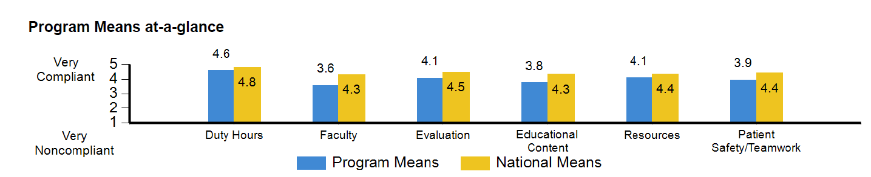 |  |  | Up, Consistent, Down or Up and Down
Duty Hours
Faculty
Evaluation
Education Content
Resources
Patient Safety
Teamwork
Overall Evaluation of Program  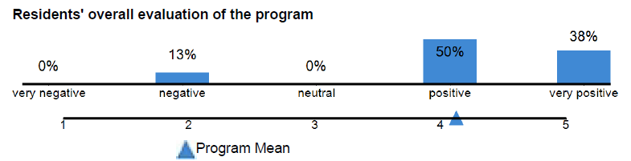 | Very Negative:  Negative:  Neutral: | Discuss Action Plans for Investigating Low Scores:
Concerning Trends: Discuss 3-year trends or significant drops in any one area
Action Plan for any Area that is (Each SI will need to create the cut-off threshold) | Area | Action Plan | Measure of Plan | Person(s) Responsible
Faculty Survey Results | 20__ | 20__ | 20__ | Trends
Area | 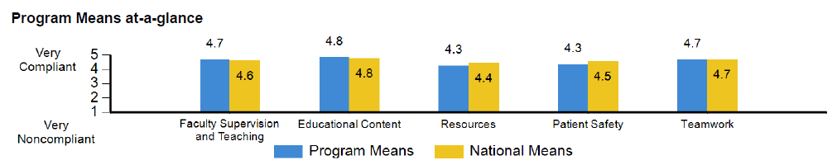  Put the score that you find at the top of your ACGME Survey |  |  | Up, Consistent, Down or Up and Down
Faculty Supervision & Training
Educational Content
Resources
Patient Safety
Teamwork
Overall Evaluation of Program | Very Negative:  Negative:  Neutral: | Discuss Action Plans for Investigating Low Scores:
Concerning Trends: Discuss 3-year trends or significant drops in any one area
Action Plan for any Area that is (Each SI will need to create the cut-off threshold) | Area | Action Plan | Measure of Plan | Person(s) Responsible
- Written Evaluations of the Program (Internal) | Discuss findings from the trainee survey | Action plans | Discuss findings from the faculty survey | Action plans
When was the internal survey administered? __________________

Section VI: Program Metrics
- Achievement of Milestones
Trainee Milestone Averaged by Core Competency Area | PGY-1 | PGY-2 | PGY-3 | PGY-4
Patient Care
Medical Knowledge
Practice-Based Learning & Improvement
Systems-based Practice
Professionalism
Communication & Interpersonal Skills
- Board Pass Rate/Certification Rate
 | 20__ | 20__ | 20__ | Trend
# of graduates over 3 years
# of examinees
# passing over 3 years
- In-training Exam
State how the average for each training year compares to all those who take the exam (in the same training year) | PGY-1 | PGY-2 | PGY-3 | PGY-4
- Graduate Performance
 | Job placement of graduates: | Fellowship placement of graduates: | Trends from exit interviews: | Trends from graduate surveys:
- Faculty Evaluation | Statistics for Aggregate Faculty Evaluation | Lowest area on aggregate faculty evaluations | Action plans for improving this area on the faculty evaluations
- Faculty Development | 20__ | 20__ | 20__
Education
Quality Improvement & Patient Safety
Fostering their Own and Resident Well-being
Patient care improvement based on practice-based learning
Based upon the review of sources of data related to the Professional Development, what are the action plans the PEC has in place to improve this area?
Section VII: Final Comments
Please provide narrative that will allow the GMEC to understand your program. This might include specifics from your program that you review in your APE but is not discussed in this report.

Please attach the following to your APE for GMEC Reporting
- Trainee/Faculty Scholarly Activity (include table of type of activity) and List of Specific Scholarly Activities
- ITE training results
- Faculty Development Activities for 20__-20__
- Action Plans from 20__-20__ APE
- New Action plans for 20__-20__
- Letters from ACGME
- ACGME Survey Results

- Trainee/Faculty Scholarly Activity (include table of type of activity) and list of specific scholarly activities
Number of Faculty Scholarly Activity by Type | 20__ | 20__ | 20__ | 20__
Research in basic science, education, translational science, patient care, or population health
Peer-reviewed grants
Quality improvement and/or patient safety initiatives
Systematic reviews, meta-analyses, review articles, chapters in medical textbooks, or case reports
Creation of curricula, evaluation tools, didactic educational activities, or electronic materials
Contribution to professional committees, educational organizations, or editorial boards
Innovations in education

Number of Trainee Scholarly Activity by Type | 20__ | 20__ | 20__ | 20__
Research in basic science, education, translational science, patient care, or population health
Peer-reviewed grants
Quality improvement and/or patient safety initiatives
Systematic reviews, meta-analyses, review articles, chapters in medical textbooks, or case reports
Creation of curricula, evaluation tools, didactic educational activities, or electronic materials
Contribution to professional committees, educational organizations, or editorial boards
Innovations in education

List of Faculty Scholarly Activity (title, date, type of activity, etc.)
List of Trainee Scholarly Activity (title, date, type of activity, etc.)

- In-training Examination Results

- Faculty Development Activities

- Action Plans

