**Partners® Template:**

Developing GME Curriculum

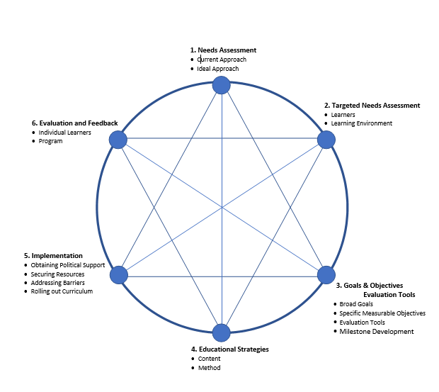

*Adapted from Curriculum Development for Medical Education: A Six-step Approach. Editors: Thomas, PA; Kern DE; Hughes MT; Chen, BY. John Hopkins University Press; Baltimore, MD; 2016.*