Tracking Faculty Development – Sponsoring Institution

Whether an excel spreadsheet, or a residency management system (RMS), you will need to have the following categories/fields:
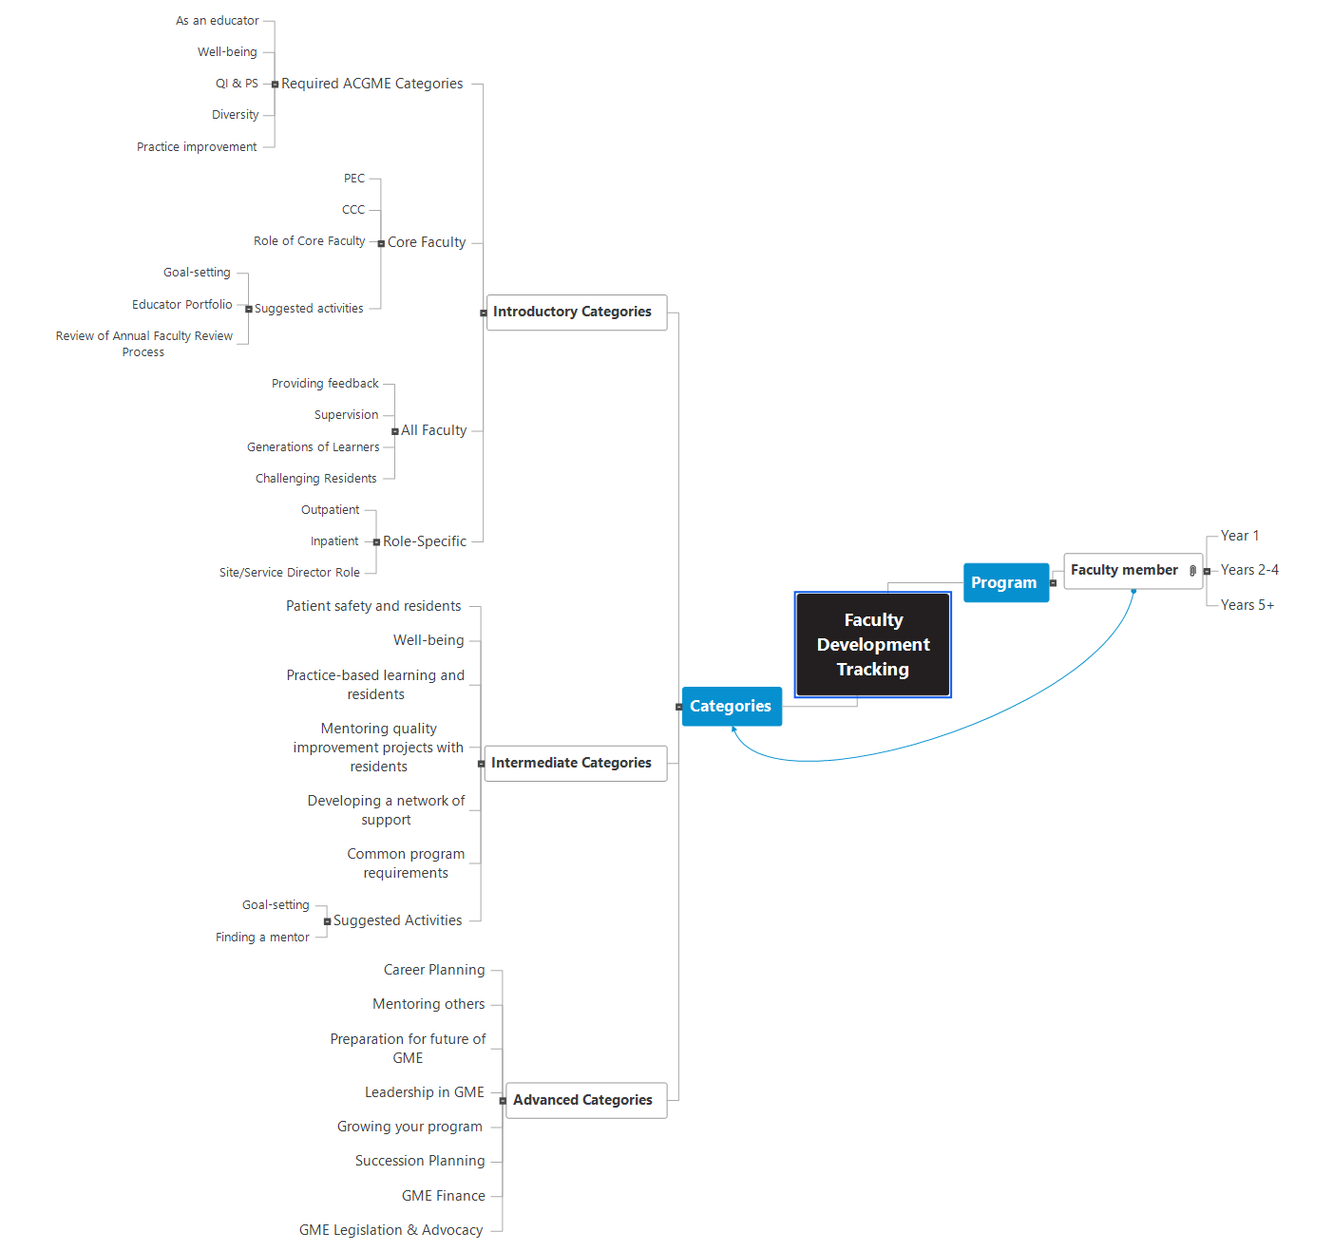
Consider the different types of reports you might need to ensure that you have the right set-up.
- Aggregate faulty development by category for AIR
- Aggregate faculty development by program for APE
- Aggregate faculty development by individual faculty member for ANNUAL REVIEW OF FACULTY

