Activity 1: Learning Theory Principles

Adults will learn best:
- Relevant: Practical learning and content that is related to ____________ or ___________.
- Individualized: self-directed activities where they have a say in the _____________ and _____________ of their learning.
- Problem-solving: Centered on _______________ ________________ (e.g., case-based learning)
- Experience: Adding to what has been _______________________ (experienced) in the past

Word Bank:

learned
problems
work
process
solving
content
personal life

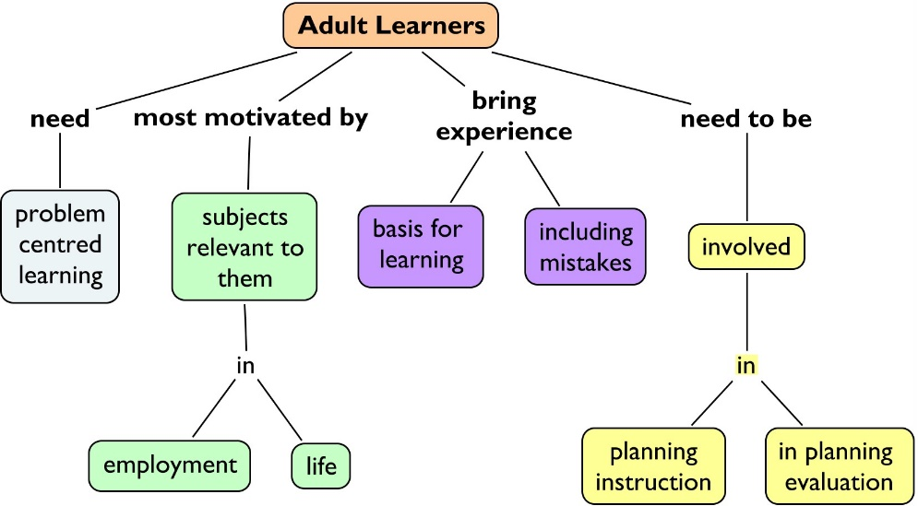

Activity 2: Active vs Passive Learning

Passive | Could go either way | Active

Where would you put these GME learning activities on the continuum above

- Patient rounds with attendings
- M&M
- Journal club
- Lecture
- Simulation
- Mock Codes
- Bedside teaching
- Role play
- Discussions
- Case discussions
- Quality improvement projects
- Setting individual learning goals
- Required readings
- Online learning modules

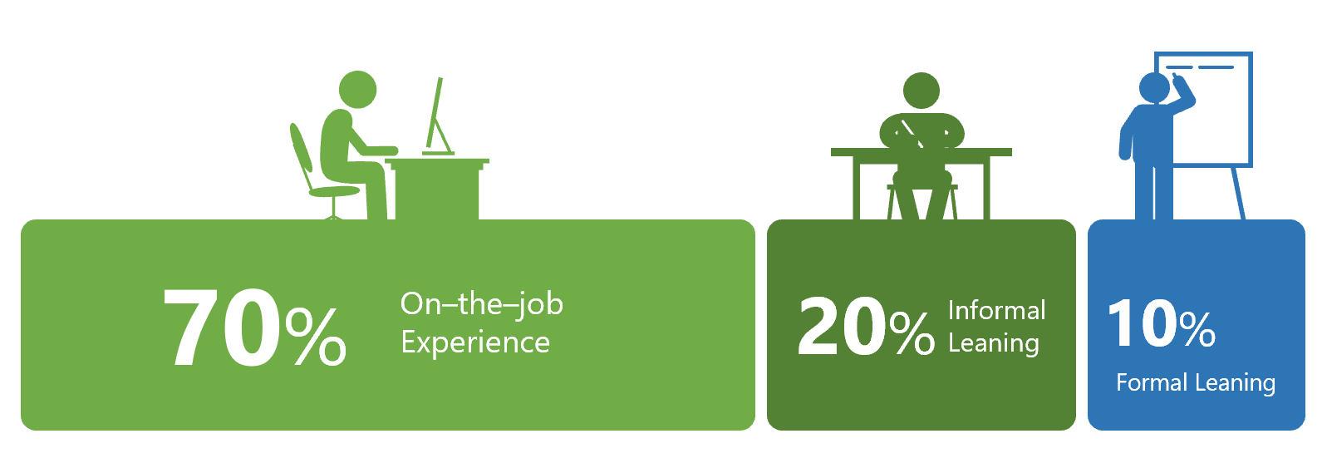

Activities 3: Learning More about Adult Learning Theory

Pedagogy (Teacher-centered) or Andragogy (Learner-centered)
p=pedagogy/a=andragogy
___ 1. independent, self-directed learning activities
___ 2. evaluation is accomplished through external methods (lectures, assigned readings)
___ 3. planning and assessment is a collaborative activity between teacher and students
___ 4. characterized by competitiveness and value judgments
___ 5. learning environment is more informal and characterized by equality/mutual respect, and cooperation
___ 6. teaching is characterized by inquiry projects, experimentation, independent study
___ 7. planning and assessment is conducted by the teacher
___ 8. learners are externally motivated (rewards, competition, grades)
___ 9. evaluation is characterized by self-assessment
___ 10. learners are dependent
___ 11. evaluation is accomplished mainly by external methods (grades, tests & quizzes)
___ 12. learners are intrinsically motivated

Digging Deeper into Andragogy
If the tenets of andragogy (adult learning) are true, which of the following statements should be true?
___ Adults are more inclined than children to want to learn for the sake of learning and don’t need external motivation
___ Adults are more fully developed and will learn more quickly
___ Adults will want to set their own learning objectives
___ Adults will need less supervision in the learning process
___ As individuals mature, they gather a wealth of experiences that can be used as resources for learning
___ Learning that relates in direct ways to life roles (i.e., spouse, parent, employee, physician) is especially motivating
___ Concrete knowledge/skills that can be applied directly/immediately in one’s life holds greater meaning/attraction than more abstract information.

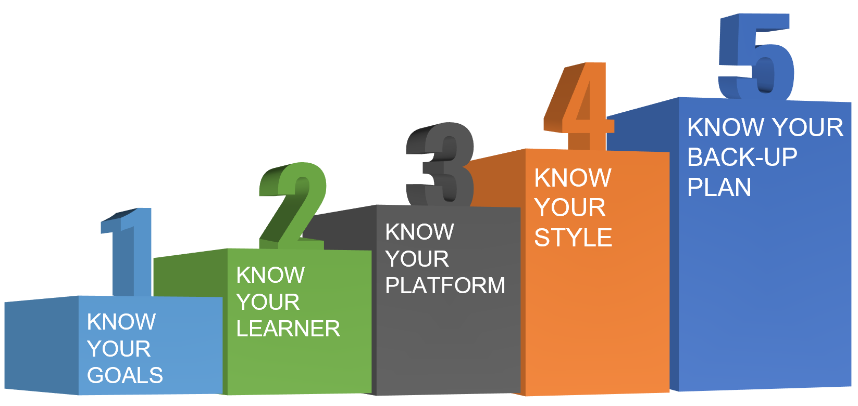

Keys to High Impact Virtual Learning

KNOW YOUR GOALS | KNOW YOUR LEARNER | KNOW YOUR PLATFORM
KNOW YOUR STYLE | KNOW YOUR BACK-UP PLAN | NOTES

