SAMPLE MEDICAL CENTER
GRADUATE MEDICAL EDUCATION
SPECIAL REVIEW COMMITTEE REPORT

A. PROGRAM REVIEWED:
ACGME ID #: | Program:
Program Director: | Coordinator:
Date of Special Review: | Report Submitted to GMEC:
Type of Special Review:

Date of Most Recent RRC Site Visit: | Date of ACGME Accreditation Letter:
Most Recent Accreditation Status: | Date of Next Self Study Site Visit:

B. SPECIAL PROGRAM REVIEW COMMITTEE:
Name | Title | Dept

INDIVIDUALS INTERVIEWED:
Title | Name
Department Chair
Program Director
Program Coordinator
Faculty (Key) Members
Residents

MATERIALS USED AND REVIEWED BY THE SPECIAL REVIEW COMMITTEE:

[Sample List of Materials used for a Special Review:]
- The ACGME Institutional, Common and Program specific standards
- The Program’s Annual Program Evaluation (APE) [and all supporting documentation]
- The Institutional Performance Indicators from the Annual Institutional Review (AIR)
- Reports of Resident and Faculty ACGME annual anonymous surveys
- Program’s Response to Citations following last Site Visit
- Program’s ACGME WebAds Annual Update (most recent update prior to Special Review)

C. CRITERIA THAT PROMPTED SPECIAL REVIEW and REVIEW PROCESS APPLIED:

[A Full Special Review is conducted when at least 3 or more Red Criteria are recorded on the Program’s Annual Program Evaluation (APE). The institution’s policy states that for a Full Special Review, the Special Review Committee must conduct an in-depth review of the program’s weaknesses to assist the program in creating an action plan. A Full Special Review includes interviews/meetings with the program leadership, faculty, and residents. ]
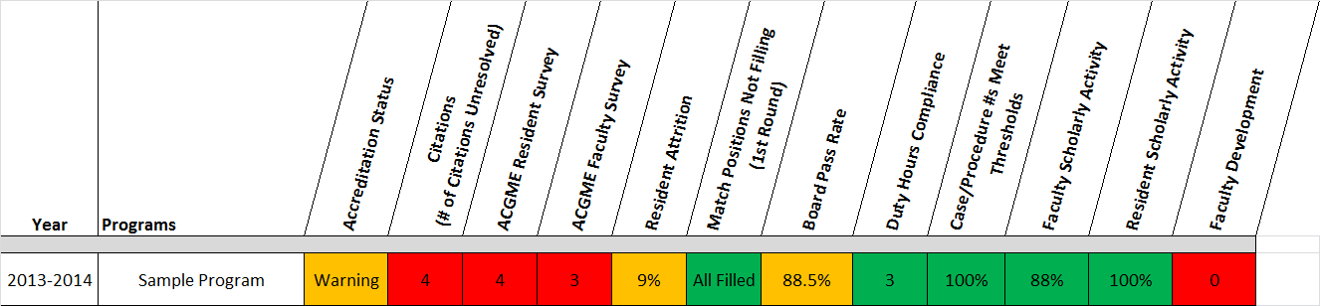

[List performance indicators that prompted special review and center questions around these areas to identify root cause of problem; provide a summary of why goals are not being met for the performance indicators according to the interviews conducted]

[Accreditation Status]

[Citations]

[ACGME Resident Survey]

[ACGME Faculty Survey]
Sufficient time to supervise residents/fellows
The program acknowledges that the core faculty feels stretched when it comes to covering their clinical assignments and finding time to actively engage the residents in academic pursuits.

Worked on scholarly project with residents/fellows
The department relies on faculty to volunteer to engage residents in scholarly activities

[Resident Attrition]

[Board Pass Rate]

[Faculty Development]

D. RESULTS OBTAINED BY THE SPECIAL REVIEW COMMITTEE

A. Quality Improvement Goals for the Program

- [Faculty Development: The Department would like to partner with the institution and Graduate Medical Education office to establish a baseline faculty development program for faculty members.]

B. Corrective Actions
[Accreditation Status]

[Citations]

[ACGME Resident Survey]

[ACGME Faculty Survey]
[The program is exploring opportunities to allow for protected time for the Sample Program core faculty members as well as possibly offering honorariums for part time faculty].

[Resident Attrition]

[Board Pass Rate]

[Faculty Development]

C. Recommendations
- [Program is advised to begin Self Study –SWOT analysis— to get a sense of what the program’s weaknesses were and what they’ve done to address the weaknesses]

GMEC MONITORING OF OUTCOMES

ISSUE | CORRECTIVE ACTIONS | PROGRESS | STATUS & DATE OF REVIEW
ACGME Faculty Survey | [Sufficient time to supervise residents/fellows; Worked on scholarly project with residents/fellows  Arrange for protected time for faculty that alleviates their clinical assignments so that they may dedicate more time to resident supervision and didactic teaching] | [The department has secured at least a day of protected time for administrative and research mentorship for all core faculty members; the core faculty will not be assigned clinical duties during their dedicated protected day each week] | [07/21/15]  [Closed]
ACGME Faculty Survey | [Offer honorariums for specialty lectures] | [The department has applied to the finance/operations department to request an increase in budget that would allocate funds to pay voluntary faculty an honorarium of $200 for each lecture they give for the residency program] | [07/21/15]  [In Progress]

