TOOLS FOR VIRTUAL EDUCATION SUCCESS
Checklists for Planning Real-Time and Self-Paced Learning
Synchronous Checklist |  | Asynchronous Checklist
 | Check equipment: internet connection & microphone |  | Develop group discussion prompts
 | Use a timer to keep on track |  | Consider after module activities to reinforce learning
 | Plan 10 minutes chunk activities followed by short breaks |  | Create goal-setting/reflection activities
 | Stick with 5 main points to be covered and case studies or videos to support your content |  | Method for tracking compliance
 | Consider homework (Self-Directed Learning) |  | Test knowledge acquisition (tests, quizzes)

Keep these adult learning components when developing your learning content…
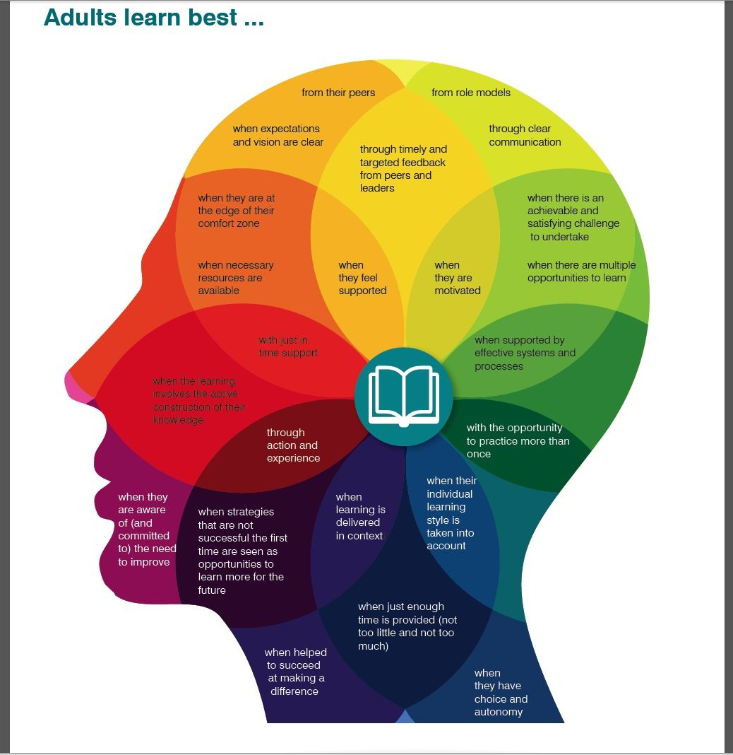

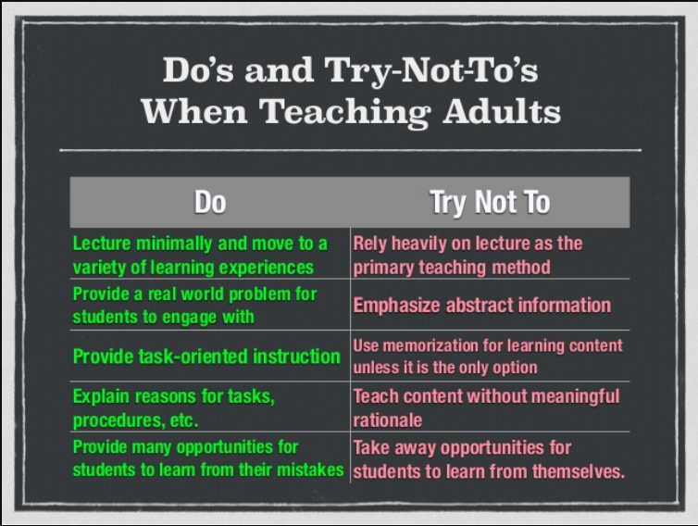
Teaching Adult Learners - TEACH Academy (slideshare.net)

